**Place/Location**: Home

**Task Description:**

Today I was working on the software logo using Photo Shop CS3 and Paint. When using paint I design a robot, there was no real motive just that I had already drawn one at one point and tough that it would go well as the software logo, so once the drawing was done I had the following:

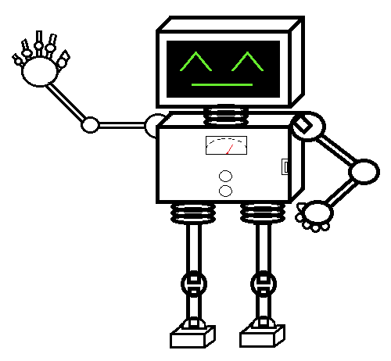

Sense this was a bit plain I then move this drawing to photo shop in order to enhance the design. Adding some Photo Shop magic which I had learned on my own time I came up with the following design:

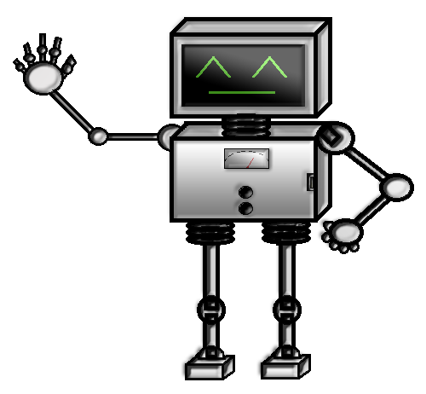

Now it looks more lifelike, a lot better the before but I felt like we needed to add something to relate it more to the Group or software so I consulted my team members for ideas.